Marine Sensitivity

Project Documentation

Ben Best

2024-10-03

Table of contents

# Preface

This is a Quarto book.

# 1. Introduction

This Marine Sensitivity (MS) project of [BOEM](https://boem.gov) seeks to assess the sensitivity of marine species to offshore energy development, whether oil & gas or wind. By combining the best available species distributions with known species sensitivities we can map out areas of the ocean that are most vulnerable to human activities. This information can be used to inform decisions about where to place energy infrastructure and/or implement mitigations to minimize impacts on the marine environment.

This is a process, not a product. Information is imperfect, especially given the large expanse of US waters. Distributions and abundance of species change, modified increasingly by climate change and human activities. Knowledge on species sensitivities continues to expand with more research. And finally the methods for both modeling and distributing all this information continue to improve. We aim to provide a transparent and reproducible process that can be regularly updated as new data and methods become available.

|  |
| --- |
| Figure 1.1: Flowchart of process for incorporating marine species sensitivities with distributions and generating a holistic vulnerability map. |

# 2. Science

The term vulnerability ($V$) is a function of exposure ($E$), sensitivity ($S$) and adaptive capacity () (Equation 2.1).

$$V=f\left(E,S,A\right) \left(2.1\right)$$

|  |
| --- |
| Figure 2.1: Overview of process. |



The raster of vulnerability ($V$) contains cells representing a sum across species ($spp$) of presence ($p$) multiplied by the sensitivity weight () (Equation 2.2).

# 3. Stressors

## 3.1 Offshore Wind Energy

Evaluation of stressors from the offshore wind industry needs to be evaluated based on human activities given the phase of development, whether pre-construction, construction, operation or decommissioning (Figure 3.1).

|  |
| --- |
| Figure 3.1: Cumulative adverse effects of offshore wind energy development on wildlife (Goodale and Milman 2016). |

## 3.2 Oil & Gas

# 4. Receptors

Receptors are the species and habitats that are potentially impacted by the human activity.

## 4.1 Species

### 4.1.1 Corals

### 4.1.2 Invertebrates

### 4.1.3 Fish

### 4.1.4 Marine Mammals

### 4.1.5 Seabirds

### 4.1.6 Sea Turtles

## 4.2 Habitats

### 4.2.1 Coral Reefs

### 4.2.2 Hydrothermal Vents

### 4.2.3 Kelp Forests

### 4.2.4 Mangrove Forests

### 4.2.5 Seamounts

## 4.3 Primary Productivity

Primary productivity is specified in the explicit mandate for BOEM’s management, per the Outer Continental Shelf Lands Act (OCSLA), Section 18(a)(2) of the OCSLA Amendments of 1978 specifying 8 factors the USDOI must consider in the timing and location of OCS oil and gas activities, including “the relative environmental sensitivity and marine productivity of different areas of the OCS.” (Balcom et al. 2011)

We processed the Vertically Generalized Production Model (VGPM) product from [Oregon State’s Ocean Productivity Lab](http://sites.science.oregonstate.edu/ocean.productivity) (using the script [vg.R](https://github.com/offshorewindhabitat/offhabr/blob/main/data-raw/datasets/vg.R)) (Figure 4.1).

|  |
| --- |
| Figure 4.1: Primary productivity throughout the continental United States averaged across months of 2021, as measured by Oregon State’s Vertically Generalized Production Model (VGPM). Expansion is anticipated across the entire US EEZ and for more recent years. |

# 5. Exposure

Cumulative exposure (Figure 3.1) is important for understanding impacts to a population.

# 6. Scoring

## 6.1 Visualization

We are in process with sorting the scoring methodology informed by visualization approaches.

### 6.1.1 Treemap

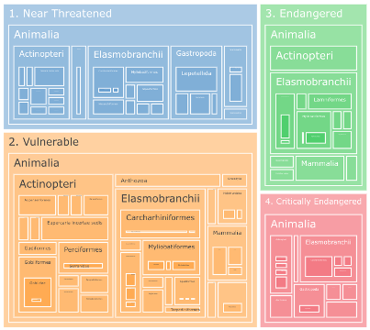

* Audience: scientists
* Show contribution of each element to a given pixel or area of interest
* Elements can be hierarchical across Sensitivity metrics and/or taxonomy
* Interactively zoom, e.g.: 4. Critically Endangered > Animalia > Mammalia  
  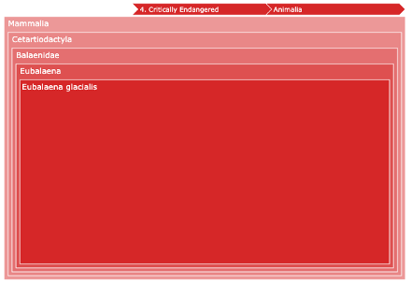

### 6.1.2 Flower Plot

* **Petal Length**  
  “One question was about the meaning of the numbers on the pedal plot. I explained that a higher sensitivity score indicates an area that could be susceptible to minor perturbations, while a lower score suggests an area that is more robust to minor changes.” - TW
  + **OHI**  
    In the original Ocean Health Index (Halpern et al. 2012), the length of the petal reflected the percent towards maximum sustainability of the given goal. The framework is also based on a reference point, either spatially or temporally (Samhouri et al. 2012).
  + **RESA ’25**  
    It makes sense to make the most vulnerable the highest score, so a low score is preferable (versus a preferred high score for sustainability of an OHI goal). We’ll need to determine what the “highest” score means as a reference point and consider [SMART criteria](https://en.wikipedia.org/wiki/SMART_criteria). (Specific, Measurable, Assignable, Realistic, Time-related). Will the reference point be the same globally or vary based on some regional maximum?
* **Petal Width** (and possiblyvarying weights)  
  “Another question was about how we manage the weights. I mentioned that we are not currently applying weights, but someone seemed concerned about it. We can discuss this further if needed.” - TW
  + **OHI**  
    For the OHI flower plot, the width of the petal represents its weight contributing to the weighted average score in the center of the flower. The varying importance of each goal is based on societally held values with potentially different value sets, such as preservationist vs extractive:  
    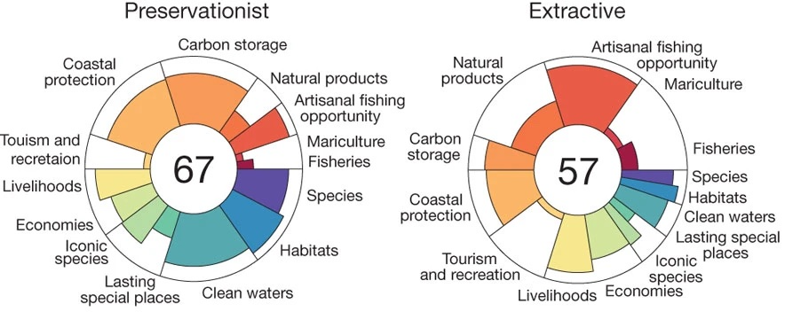
  + **RESA ’25**  
    For the RESA ’25, when looking at Species, Habitats and Primary Productivity, how shall they be weighted to factor into a final score? Shall species groups be simply weighted based on the number of species within, total biomass, extinction risk, commercial value, etc? And then Species versus less numerous Benthic Habitats and a singular value for Primary Productivity? I will conduct a literature survey to assign sensible value sets, but an App could also apply a user-defined value set to assign weights. That gets messy, but if transparent and easy ideally would lead to scientific consensus with a workshop and/or survey.  
    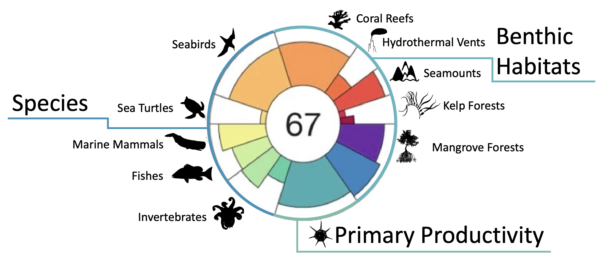

# 7. Software

We ascribe to the philosophy of sharing all code for the sake of reproducibility, transparency and efficiency (Maitner et al. 2024; Lowndes et al. 2017); i.e. the FAIR principles of Findability, Accessibility, Interoperability, and Reusability (Wilkinson et al. 2016).

### 7.0.1 Interactive Applications

We have developed a series of interactive applications to explore the data and results of the MS project. These applications allow users to visualize the data, explore the results, and interact with the data in a more intuitive way. The applications are built using the [shiny](https://shiny.posit.co) package in R, which allows us to easily create a user interface with complex reactivity for an interactive web application easily accessed through a web browser. The applications are designed to be user-friendly and intuitive, with interactive maps, charts, and tables that allow users to explore the data in a more dynamic way.

### 7.0.2 Overcoming Challenges with Large Spatial Data

The MS project incorporates many large spatial datasets that are problematic to render in a typical interactive application. For instance, the most common interactive mapping R package leaflet has a 4MB limitation for displaying rasters (see “Large Raster Warning” in [Raster Images • leaflet](https://rstudio.github.io/leaflet/articles/raster.html#large-raster-warning)). Vectors (i.e., points, lines and polygons) get smoothed when containing many vertices, but contiguity gets lost between polygons and rendering degrades to non-usable depending on the internet speed of the user’s connection.

To work around these limitations, we have implemented “cloud native” web services and formats (see also [Cloud-Optimized Geospatial Formats Guide](https://guide.cloudnativegeo.org/)). Our implementations effectively reduce the size of any given spatial object based on the zoom level of the user’s browser. For rasters, we use cloud-optimized GeoTIFFs (COGs) and for vectors, we use Mapbox Vector Tiles (MVT). These formats are designed to be fast and efficient for web mapping applications, and they allow us to display large spatial datasets in an interactive web application without sacrificing performance or usability. Let’s take a closer look at implementation of each.

#### 7.0.2.1 Raster: Cloud-Optimized GeoTIFFs (**COGs**) and **Titiler**

Historically, to read a raster, such as a GeoTIFF, from the web, the client software would have to read the entire file before rendering. Cloud Optimized GeoTIFFs ([COGs](https://www.cogeo.org)) take advantage of [HTTP GET range requests](https://tools.ietf.org/html/rfc7233) to read only the part of the file needed for rendering. So a COG stores quadtree simplifications of the original raster at multiple zoom levels and metadata for accessing their byte ranges in the file in the metadata header. This allows the client software to request only the parts of the file needed for rendering, which can greatly reduce the amount of data transferred and speed up rendering. This is for accessing the raw data in pixel values, e.g., for a raster of species distribution then the abundance of a species in each cell. We would want to also apply a color ramp to visualize the data. The open-source ([TiTiler](https://developmentseed.org/titiler/) software is a lightweight web service that serves up these color ramped tiles on the fly. So COGs can be stored on a simple file server (like Amazon S3 or Azure Blob Storage) and served up as interactive web maps with TiTiler as an intermediary between the COG files and the client accessing the interactive Shiny mapping app (Figure 7.1).

|  |
| --- |
| Figure 7.1: Sequence diagram implementing large raster interactive display using Cloud-Optimized GeoTIFFs (COGs) and Titiler in a Shiny mapping app. |

#### 7.0.2.2 Vector: Mapbox Vector Tiles (**MVTs**) and **pg_tileserv**

Although “cloud native” vector formats exist for simple file storage (see [Cloud-Optimized Geospatial Formats Guide](https://guide.cloudnativegeo.org/)), none of these allow for flexible filtering and manipulation. Instead, we use PostgreSQL with the spatial extension ([PostGIS](https://postgis.net)) to store the vector data and serve it as Mapbox Vector Tiles ([MVTs](https://docs.mapbox.com/vector-tiles/specification/)) using the [**pg_tileserv**](https://github.com/CrunchyData/pg_tileserv) web service written in the language Go, which is very fast. This means that we don’t have to pre-render the MVTs (such as you might do with [tippecanoe](https://github.com/mapbox/tippecanoe)), but can instead serve the raw vector data directly from the database and let **pg_tileserv** handle the rendering on the fly. Filters (in the form of [CQL](https://github.com/CrunchyData/pg_tileserv/blob/master/hugo/content/usage/cql.md)) can be applied to the request. Symbology is rendered client-side via JavaScript, which allows for interactive hover and click events on vector objects (e.g., BOEM aliquot). Some speed-up is enabled by implementing a [Varnish](https://varnish-cache.org) cache service in between. We can even write our own database functions for customized rendering, such as H3 hexagonal summaries. This allows us to serve vector data as web maps with minimal configuration and setup, and it provides a fast and efficient way to display large vector datasets in an interactive web application (Figure 7.2).

|  |
| --- |
| Figure 7.2: Sequence diagram implementing large vector interactive display using Mapbox Vector Tiles (MVTs) and pg_tileserv in a Shiny mapping app. |

### 7.0.3 Github Repositories

| repo | description |
| --- | --- |
| [api](https://github.com/MarineSensitivity/api) | application programming interface (API) using R Plumber package |
| [apps](https://github.com/MarineSensitivity/apps) | Shiny applications |
| [docs](https://github.com/MarineSensitivity/docs) | documentation for BOEM’s offshore environmental sensitivity index products |
| [manuscripts](https://github.com/MarineSensitivity/manuscripts) | Manuscripts with review of sensitivities by industry and receptors (species, habitats, human uses) |
| [MarineSensitivity.github.io](https://github.com/MarineSensitivity/MarineSensitivity.github.io) | default website |
| [msens](https://github.com/MarineSensitivity/msens) | R library of functions for mapping marine sensitivities, sponsored by BOEM |
| [objectives](https://github.com/MarineSensitivity/objectives) | repository for issues spanning multiple repositories and doing big picture roadmapping |
| [server](https://github.com/MarineSensitivity/server) | server setup for R Shiny apps, RStudio IDE, R Plumber API, PostGIS database, pg_tileserv |
| [workflows](https://github.com/MarineSensitivity/workflows) | scripts for testing data analytics and visualization as well as production workflows |

### 7.0.4 Software Components

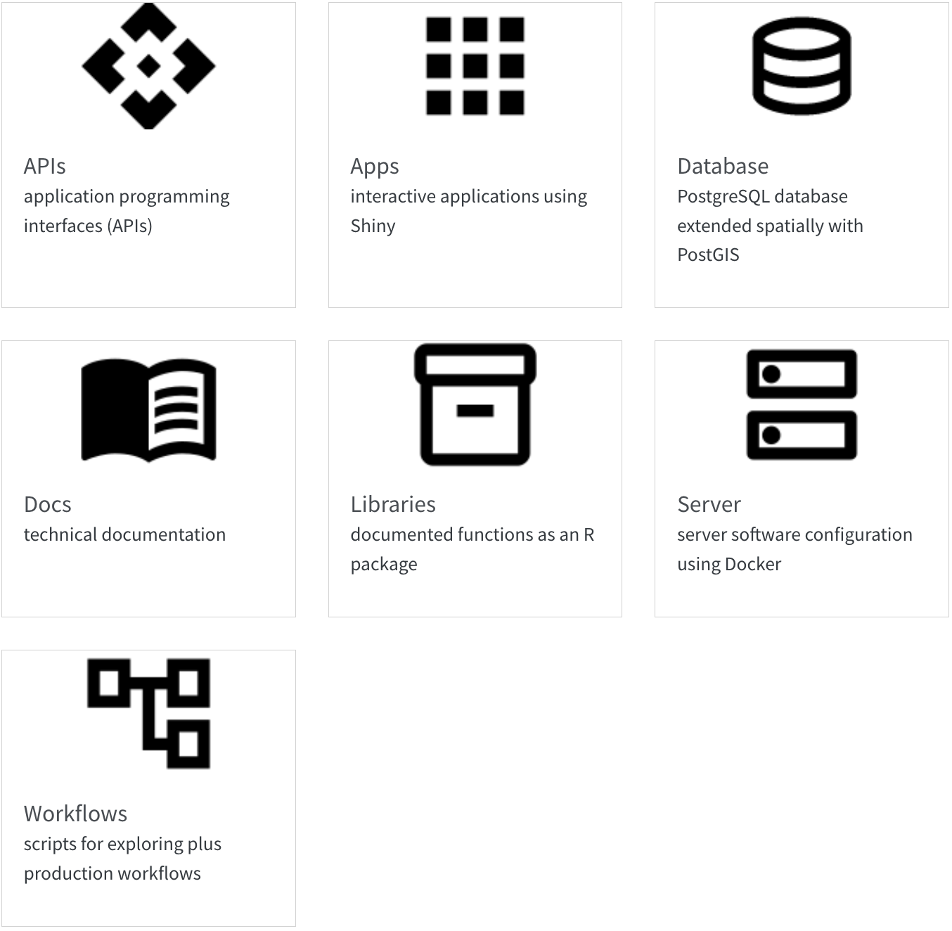

# 8. Server

The server is for serving up any web services outside those of Github (e.g., [website](https://marinesensitivity.org/), [docs](https://marinesensitivity.org/docs) and R package [msens](https://marinesensitivity.org/msens)) using [Docker](https://www.docker.com/) (see the [docker-compose.yml](https://github.com/MarineSensitivity/server/blob/main/docker-compose.yml); with reverse proxying from subdomains to ports by [Caddy](https://caddyserver.com)).

## 8.1 Setup

For the latest instructions on launching an Amazon instance and installing the server software, see [Server Setup · MarineSensitivity/server Wiki](https://github.com/MarineSensitivity/server/wiki/Server-Setup), which is pasted below for convenience:

*on AWS as EC2 instance using Docker*

### 8.1.1 Launch instance

name: **msens1**:

* Software Image (AMI)  
  Canonical, **Ubuntu**, 22.04 LTS, amd64 jammy image build on 2023-09-19 ami-0fc5d935ebf8bc3bc
* Virtual server type (instance type)  
  **t2.xlarge** (4 vCPU, 16 GB memory)
* Firewall (security group)  
  New security group
* Storage (volumes)  
  2 volume(s)
  + **20 GB**  
    / server software, disposable
  + **60 GB**  
    /share for all data, persistent and to be backed up

#### 8.1.1.1 Allocate IP address

* [Elastic IP addresses | EC2 | us-east-1](https://us-east-1.console.aws.amazon.com/ec2/home?region=us-east-1#Addresses:) for persistent IP address
* Allocated IPv4 address: 100.25.173.0
* Associate Elastic IP address

### 8.1.2 SSH to server

pem='/Users/bbest/My Drive/private/msens_key_pair.pem'  
ssh -i $pem ubuntu@msens1.marinesensitivity.org

#### 8.1.2.1 Set hostname

* [Change the hostname of your Amazon Linux instance - Amazon Elastic Compute Cloud](https://docs.aws.amazon.com/AWSEC2/latest/UserGuide/set-hostname.html)

sudo vi /etc/cloud/cloud.cfg  
# preserve_hostname: true  
sudo hostnamectl set-hostname msens1.marinesensitivity.org  
sudo reboot

#### 8.1.2.2 Mount volume

The extra volume (60 GB for /share) was added during EC2 launch instance wizard, but needs to be mounted before available for use.

* [Make an Amazon EBS volume available for use on Linux - Amazon Elastic Compute Cloud](https://docs.aws.amazon.com/AWSEC2/latest/UserGuide/ebs-using-volumes.html)

df -H

Filesystem Size Used Avail Use% Mounted on  
/dev/root 21G 2.3G 19G 11% /  
tmpfs 8.4G 0 8.4G 0% /dev/shm  
tmpfs 3.4G 898k 3.4G 1% /run  
tmpfs 5.3M 0 5.3M 0% /run/lock  
/dev/xvda15 110M 6.4M 104M 6% /boot/efi  
tmpfs 1.7G 4.1k 1.7G 1% /run/user/1000

lsblk

NAME MAJ:MIN RM SIZE RO TYPE MOUNTPOINTS  
loop0 7:0 0 24.6M 1 loop /snap/amazon-ssm-agent/7528  
loop1 7:1 0 55.7M 1 loop /snap/core18/2790  
loop2 7:2 0 63.5M 1 loop /snap/core20/2015  
loop3 7:3 0 111.9M 1 loop /snap/lxd/24322  
loop4 7:4 0 40.8M 1 loop /snap/snapd/20092  
xvda 202:0 0 20G 0 disk   
├─xvda1 202:1 0 19.9G 0 part /  
├─xvda14 202:14 0 4M 0 part   
└─xvda15 202:15 0 106M 0 part /boot/efi  
xvdb 202:16 0 60G 0 disk

sudo file -s /dev/xvdb  
# /dev/xvdb: data

So no file system on /dev/xvdb yet.

sudo mkfs -t xfs /dev/xvdb  
sudo mkdir /share  
sudo mount /dev/xvdb /share

sudo cp /etc/fstab /etc/fstab.orig  
sudo blkid  
# /dev/xvdb: UUID="bc766dfb-1c42-49cf-9320-2242a2d48a2e" BLOCK_SIZE="512" TYPE="xfs"  
sudo vim /etc/fstab  
# UUID=bc766dfb-1c42-49cf-9320-2242a2d48a2e /share xfs defaults,nofail 0 2  
  
df -h  
sudo umount /share ; df -h  
sudo mount -a ; df -h

### 8.1.3 Install Docker

Following:

* [Step-by-Step Guide to Install Docker on Ubuntu in AWS | by Srija Anaparthy | Medium](https://medium.com/@srijaanaparthy/step-by-step-guide-to-install-docker-on-ubuntu-in-aws-a39746e5a63d)

sudo apt-get update  
#OLD: sudo apt-get install docker.io -y

NEW: [[Migrate to docker compose]]

sudo systemctl start docker  
sudo docker run hello-world  
sudo systemctl enable docker  
docker --version  
# Docker version 24.0.6, build ed223bc  
sudo usermod -a -G docker $(whoami)

#### 8.1.3.1 Run docker compose

* /Users/bbest/My Drive/private/[msens_server_env-password.txt](https://drive.google.com/open?id=17B3djETDU8SVwGvJdZ3rp7TKtX8w0cfl&usp=drive_fs)

sudo chown -R ubuntu:ubuntu /share  
mkdir -p /share/github/MarineSensitivity  
cd /share/github/MarineSensitivity  
# clone server repo  
git clone https://github.com/MarineSensitivity/server.git  
cd server  
  
# add password, used as $PASSWORD in docker-compose.yml  
echo 'PASSWORD=******' > .env  
  
# launch docker instances  
sudo docker-compose up -d

### 8.1.4 Backup /share with snapshots

Per [Automate snapshot lifecycles - Amazon Elastic Compute Cloud](https://docs.aws.amazon.com/AWSEC2/latest/UserGuide/snapshot-ami-policy.html#create-snap-policy), created two policies: - **bkup_msens-share_daily** every 24 hrs at 09:00 UTC, max of 7 - **bkup_msens-share_weekly** every Monday 09:00 UTC, max of 8

## 8.2 Services

The server is running the following services:

* [**RStudio**](https://rstudio.marinesensitivity.org)  
  *integrated development environment (IDE) to code and debug directly on the server*  
    
  [More info..](https://posit.co/products/open-source/rstudio-server/)
* [**Shiny**](https://shiny.marinesensitivity.org)  
  *interactive applications*  
  e.g., [**shiny**.marinesensitivity.org/**map**](https://shiny.marinesensitivity.org/map)  
    
  [More info..](https://shiny.posit.co/)
* [**PGadmin**](https://pgadmin.marinesensitivity.org)  
  *PostGreSQL database administration interface*  
    
  [More info..](https://www.pgadmin.org/)
* [**api**](https://api.marinesensitivity.org)  
  *custom API: using R plumber*  
    
  [More info..](https://www.rplumber.io/)
* [**swagger**](https://swagger.marinesensitivity.org)  
  *generic database API: using PostGREST*  
    
  [More info..](https://postgrest.org/en/stable/)
* [**tile**](https://tile.marinesensitivity.org)  
  *spatial database API: using pg_tileserv for serving vector tiles*  
    
  [More info..](https://github.com/CrunchyData/pg_tileserv)

# 9. Database

## 9.1 Table and Column Naming Conventions

* Table names are plural and use all lower case.
* Unique identifiers are suffixed with:
  + *_id for unique integer keys;
  + *_key for unique string keys;
  + *_seq for auto-incrementing sequence integer keys.
* Column names are singular and use snake_case.
* Foreign keys are named with the singular form of the table they reference, followed by _id.
* Primary keys are named id.

## 9.2 Species Distribution Models

See entity relationship diagram (ERD) for the species distribution models (SDM) database tables in this workflow:

* [Create SDM Tables](https://marinesensitivity.org/workflows/create_sdm-tables.html)

And example of ingesting SDM outputs into the database in this workflow:

* [Ingest GoMex cetacean & sea turtle SDMs](https://marinesensitivity.org/workflows/ingest_sdm-gm.html)

# 10. Workflows

Workflows are scripts for testing data analytics and visualization as well as production workflows for ingesting data. See:

* [marinesensitivity.org/workflows](https://marinesensitivity.org/workflows/)  
  rendered html pages from the scripts (as Quarto notebooks)
* [github.com/MarineSensitivity/workflows](https://github.com/MarineSensitivity/workflows)  
  source code in the Github repository

# 11. APIs

There three APIs, each used for different purposes:

1. [**api**](https://api.marinesensitivity.org)  
   *custom API: using R* [*plumber*](https://www.rplumber.io/)  
   source: [MarineSensitivity/api](https://github.com/MarineSensitivity/api/blob/main/plumber.R)  
   
2. [**swagger**](https://swagger.marinesensitivity.org)  
   *generic database API: using* [*PostGREST*](https://postgrest.org/en/stable/)  
   source: Postgres database, non-spatial  
   
3. [**tile**](https://tile.marinesensitivity.org)  
   *spatial database API: using* [*pg_tileserv*](https://postgrest.org/en/stable/) *for serving vector tiles*  
   source: Postgres database, spatial  
   

# 12. Libraries

By creating an R package, we can document functions and make them easily available to other users.

* [msens](https://github.com/MarineSensitivity/msens)  
  R library of functions for mapping marine sensitivities, sponsored by BOEM

Functions can ***read*** data from the one [APIs](apis.qmd) (which communicate with the [Database](db.qmd)), ***analyze*** the data, ***visualize*** the results and store some smaller ***data***.

# 13. Apps

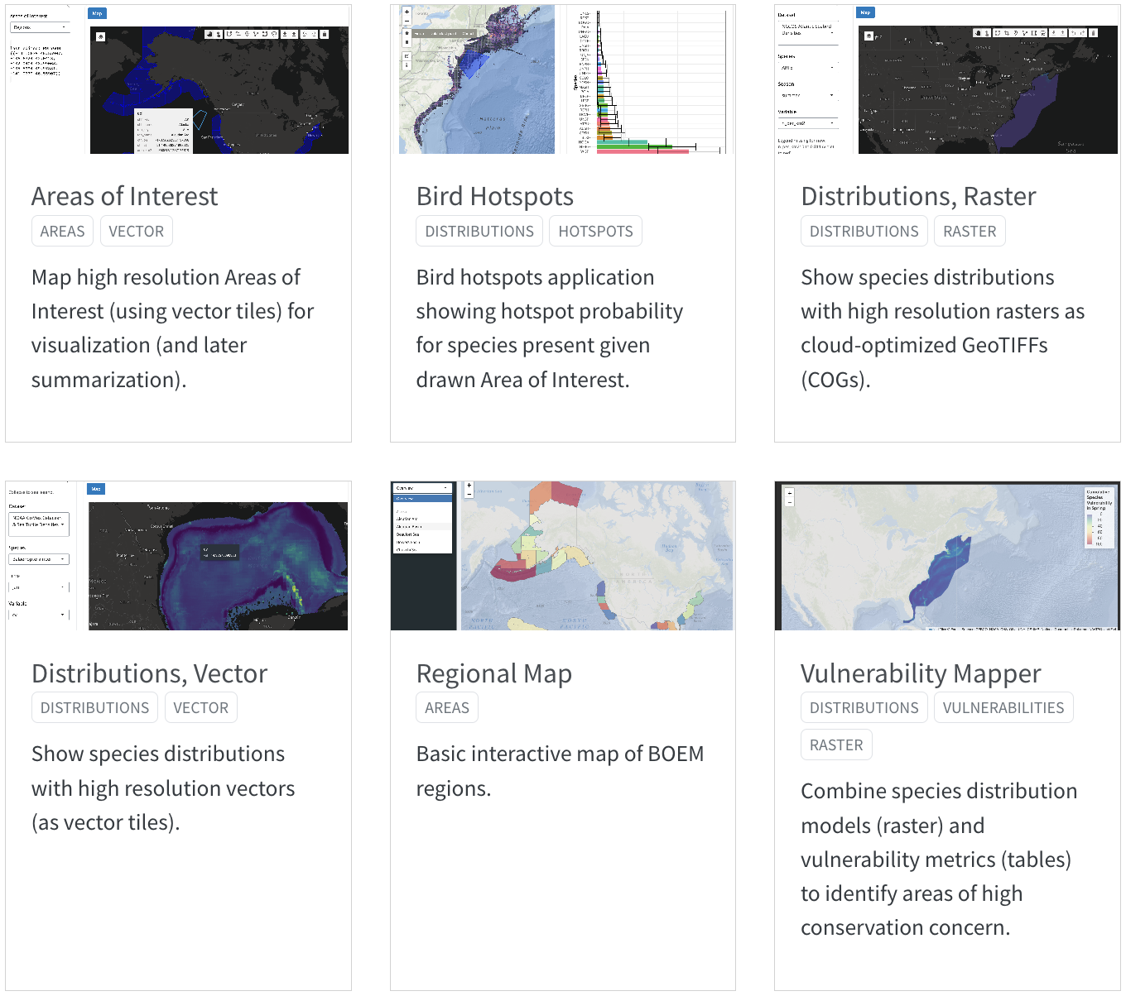

See also details of individual applications in the Appendix.

# 14. Docs

Technical documentation is principally in this book:

* [marinesensitivity.org/docs](https://marinesensitivity.org/workflows/)  
  the main documentation site
* [github.com/MarineSensitivity/docs](https://github.com/MarineSensitivity/workflows)  
  source code in the Github repository

But there are also some other self-documenting resources:

* [marinesensitivity.org/msens](https://marinesensitivity.org/faq/)  
  documented R functions

# 15. Summary

…

# References

Balcom, Brian J., Douglas C. Biggs, Chuanmin Hu, Paul Montagna, and Dean A. Stockwell. 2011. “A Comparison of Marine Productivity Among Outer Continental Shelf Planning Areas. Final Report.”

Goodale, M. Wing, and Anita Milman. 2016. “Cumulative Adverse Effects of Offshore Wind Energy Development on Wildlife.” *Journal of Environmental Planning and Management* 0 (0): 1–21. <https://doi.org/10.1080/09640568.2014.973483>.

Halpern, Benjamin S., Catherine Longo, Darren Hardy, Karen L. McLeod, Jameal F. Samhouri, Steven K. Katona, Kristin Kleisner, et al. 2012. “An Index to Assess the Health and Benefits of the Global Ocean.” *Nature*. <https://doi.org/10.1038/nature11397>.

Lowndes, Julia S. Stewart, Benjamin D. Best, Courtney Scarborough, Jamie C. Afflerbach, Melanie R. Frazier, Casey C. O’Hara, Ning Jiang, and Benjamin S. Halpern. 2017. “Our Path to Better Science in Less Time Using Open Data Science Tools.” *Nature Ecology & Evolution* 1 (6): 0160. <https://doi.org/10.1038/s41559-017-0160>.

Maitner, Brian, Paul Efren Santos Andrade, Luna Lei, Jamie Kass, Hannah L. Owens, George C. G. Barbosa, Brad Boyle, et al. 2024. “Code Sharing in Ecology and Evolution Increases Citation Rates but Remains Uncommon.” *Ecology and Evolution* 14 (8): e70030. <https://doi.org/10.1002/ece3.70030>.

Ross, Pauline M., Elliot Scanes, Maria Byrne, Tracy D. Ainsworth, Jennifer M. Donelson, Shawna A. Foo, Pat Hutchings, Vengatesen Thiyagarajan, and Laura M. Parker. 2023. “Surviving the Anthropocene: The Resilience of Marine Animals to Climate Change.” In. CRC Press.

Samhouri, Jameal F., Sarah E. Lester, Elizabeth R. Selig, Benjamin S. Halpern, Michael J. Fogarty, Catherine Longo, and Karen L. McLeod. 2012. “Sea Sick? Setting Targets to Assess Ocean Health and Ecosystem Services.” *Ecosphere* 3 (5): 1–18. <https://doi.org/10.1890/es11-00366.1>.

Wilkinson, Mark D., Michel Dumontier, IJsbrand Jan Aalbersberg, Gabrielle Appleton, Myles Axton, Arie Baak, Niklas Blomberg, et al. 2016. “The FAIR Guiding Principles for Scientific Data Management and Stewardship.” *Scientific Data* 3 (1): 160018. <https://doi.org/10.1038/sdata.2016.18>.

# Glossary

acclimatisation

the adjustment of an organism to environmental conditions in the field or environment rather than the laboratory without an adjustment in their genetics. Acclimatisation has been used to describe phenotypically plastic responses in natural conditions. Source: Ross et al. (2023).

adaptation

the evolutionary mechanism where natural selection of traits is genetically passed on, typically over many generations, to create an organism suited to the environment. Source: [rossRoss et al. (2023)

adaptive capacity

the capacity of the ecosystem or organism to improve and reorganise in response to stress such as climate change through phenotypic plasticity (acclimation, acclimatisation) or adaptation, distributional shifts, and rapid evolution of traits suited to new conditions. Source: Ross et al. (2023).

epigenetics

the modification of phenotype plasticity of an organism through altered gene expression without an alteration to the DNA sequence. ‘Epi’ means above the DNA and includes DNA methylation, modification of histones, and non-coding RNA. Source: Ross et al. (2023).

exposure

the magnitude of the change in the environment

fecundity

the maximum physiological potential reproductive output of an organism to produce offspring (reproductive output). This differs from fertility, which is the number of offspring born. Source: Ross et al. (2023)

MBON

Marine Biodiversity Observation Network; see <MarineBON.org>

resilience

the capacity of an ecosystem, society, or organism to absorb disturbance and reorganise while undergoing change so as to retain essentially the same function, structure, identity, and feedbacks. Resilience reflects the degree to which a complex adaptive system is determined by its capacity to reorganise and adapt in order to avoid being disturbed again. Source: Ross et al. (2023).

sensitivity

the magnitude of response to the change

stressor

the stimulus that causes stress to an organism

vulnerability

combination of exposure and sensitivity

# Areas of Interest

Map high resolution Areas of Interest (using vector tiles) for visualization (and later summarization).

* [website](https://shiny.marinesensitivity.org/aoi/)
* [code](https://github.com/MarineSensitivity/apps/tree/main/aoi)



# Bird Hotspots

Bird hotspots application showing hotspot probability for species present given drawn Area of Interest.

* [website](https://shiny.marinesensitivity.org/bird_hotspots/)
* [code](https://github.com/MarineSensitivity/apps/tree/main/bird_hotspots)



# Regional Map

Basic interactive map of BOEM regions.

* [website](https://shiny.marinesensitivity.org/map/)
* [code](https://github.com/MarineSensitivity/apps/tree/main/map)



# Distributions, Vector

Show species distributions with high resolution vectors (as vector tiles).

* [website](https://shiny.marinesensitivity.org/sdm/)
* [code](https://github.com/MarineSensitivity/apps/tree/main/sdm)



# Distributions, Raster

Show species distributions with high resolution rasters as cloud-optimized GeoTIFFs (COGs).

* [website](https://shiny.marinesensitivity.org/sdm-cog/)
* [code](https://github.com/MarineSensitivity/apps/tree/main/sdm-cog)



# Vulnerability Mapper

Combine species distribution models (raster) and vulnerability metrics (tables) to identify areas of high conservation concern.

* [website](https://shiny.marinesensitivity.org/vmap/)
* [code](https://github.com/MarineSensitivity/apps/tree/main/vmap)

